Details | Sobel | Laplacian | Canny
Description | Gradient-based operator detecting horizontal and vertical intensity changes. | Second-order derivative operator emphasizing rapid intensity changes. | Multi-stage gradient detector using dual-threshold and non-maximum suppression.
Kernel | ksize = 3, ksize = 5, ksize = 7 | ksize = 3, ksize = 5, ksize = 7 | Threshold pairs (50–100), (100–200), (150–250)
Characteristics | Highlights directional gradients, kernel size affects edge thickness and smoothness. | Detects edges in all directions simultaneously, sensitive to noise. | Balances precision and sensitivity depending on threshold range.
Advantages | Effective for detecting smooth intensity transitions and curved edges. | Captures fine edge variations in all orientations. | Produces clean, accurate edges with minimal false detection.
Disadvantages | Larger kernels blur small details and reduce sharpness. | Very sensitive to image noise, may produce false edges. | Needs manual threshold tuning; can miss weak edges.
Visual Observation | Increasing kernel size results in thicker, smoother edges and less noise. | Larger kernels reduce noise and emphasize main contours. | Low thresholds detect thin noisy edges; high thresholds highlight only strong boundaries.
Table 1. Edge Detection Method Comparison

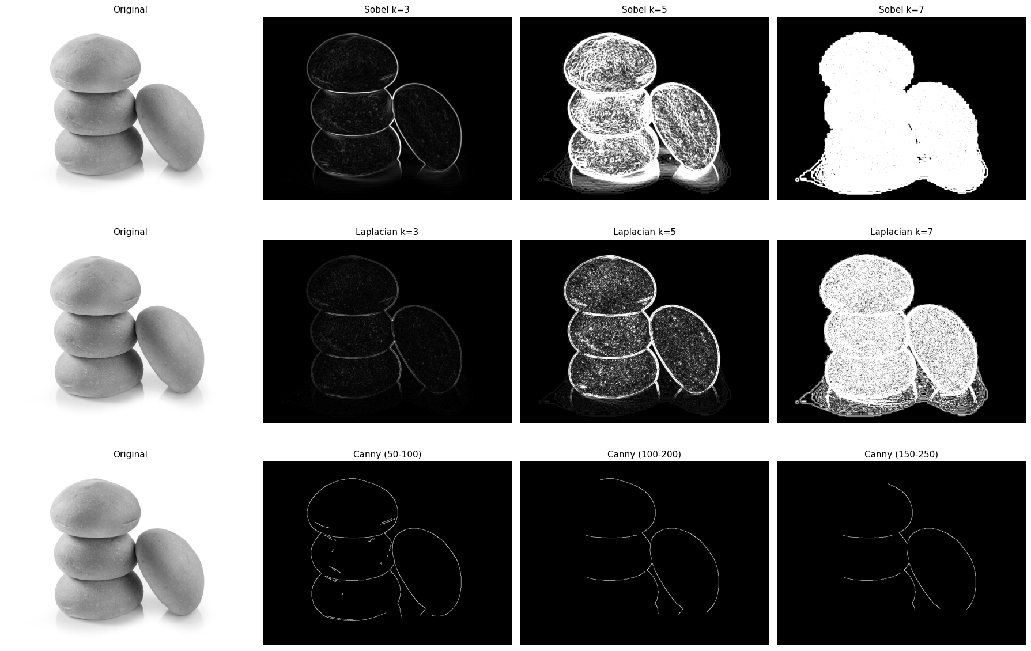
Figure 1. Output Edge Detection Comparison

